Team Snap App
All of the items outlined below can be accessed through the Team Snap App. It is highly recommended that you download the app on your mobile device and set up notifications so that you will receive updates as they occur.
From your computer
When you login with your e-mail address, you will be able to see the teams that your children are members of:
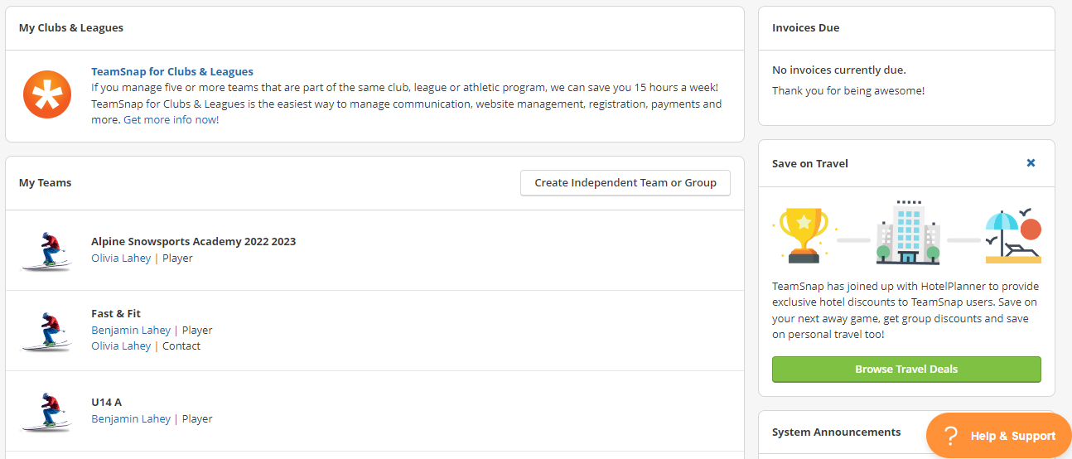
Choose a child from the list and it will open up the home page for their team. You will see a number of blue tabs at the top of the page.
Roster Tab
This will show a list of all of the athletes, coaches, and manages on your child’s team.
- Click on your child’s name to open their profile then click on the ‘edit button’ to make any changes.
- Please ensure that your cell phone is included in the profile so we have it in case of emergencies.
- If you prefer to not share your contact information with other team members you can select the ‘private’ button.
- Ensure the ‘receive email’ button is selected so you do not miss club and team communication.
- If you want other family members to receive team communication, click “add Family member” to provide their information. for older athletes, this can include the athlete themselves so that they are receiving club communications & team updates on their own devices.
- Click ‘save’ to keep changes.

Schedule Tab
Here is where you will see all the events for your team. This includes training sessions, races, and other team events. Updates will be made as schedules need to adjust and this will be the place that is most up-to-date with team schedule information.
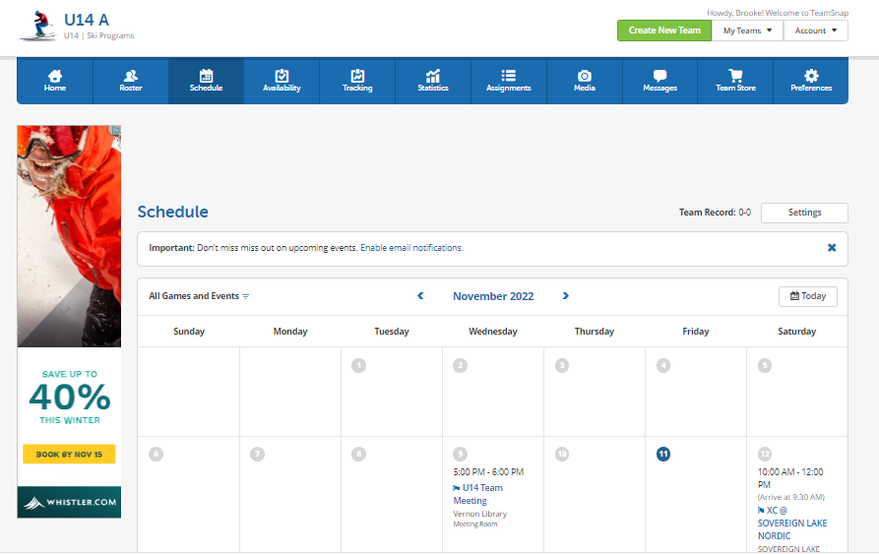
To add the calendar to an existing calendar you use (ie: Google, iCal, Outlook, etc):
- Click on the Settings button
- Click on ‘Sync calendar/export’ and follow the directions for the calendar you use

Availability Tab
Here is where you will be able to mark you child’s planned attendance for events on the team calendar (training, races, etc).
We ask that you keep this updated so that coaches know who to expect at training sessions.

Media Tab
This is where your coach may upload any photos/videos or files that might be useful to your team. You are encouraged to share photos here.

Messages Tab
Here you will see any messages that have been sent to you through Team Snap. Coaches and Parent Reps will regularly use this feature to communicate with the team.
In addition, you can send messages/alerts to your team members.
- Start by choosing which format (e-mail, alert, etc) you want to use and then use the ‘new e-mail’ (or alert) button.
- You can then type you message and choose which members of your team to send it to (all, individuals, coaches, managers, etc.)
- Note: you can only attach to emails on the desktop application, not on the mobile app.

Preferences Tab
There is an option to receive an e-mail reminder before each event in the calendar. You p can dis/enable this feature under the Preferences Tab.

